Additional Example Solutions

Week 3

Q1

* + Euclidean distance: sqrt{(4-1)2 + (2-2)2 + (2-3)2} = sqrt(10)
  + P=3 minkowski distance (note that type setting in example is incorrect – the exponential index should be 1/3:  
      
    = cube root{ 3^3 + 1^3} = 281/3
  + Distance to A = sqrt(3), Distance to B = sqrt(5), so point C is in class 0
  + New point must be compared to all other points (N comparisons)
  + Multiple tricks -see Wikipedia page on ‘nearest neighbour search’ as a starting point

Q2

* 1. K = 1
  2. K = 3, 2 points misclassified so c.v. error is 2/11

Q3

1. Book work
2. Book work (from video lecture)
3. Figure b. Figure a shows a linear kernel, c shows an rbf kernel. Note that the dotted lines show the margins, and the solid line is the decision boundary.
4. E^(x_i – x_j) can be written as a Taylor series expansion, in which each term is an inner product. As there are an infinite no. of inner products, there is also an infinite feature space.

Week 4

Q1

1. As written, car_type is the set of all possibilities {C,M,E}, so this is just H(high) = 2/3log(2/3)+1/3log(1/3). More typically, we would expect to be asked to calculate an entropy when car_type takes a particular value, e.g. H(Insurance=H | car_type = C) = 1
2. Split on sex first, then car_type. Note that sex correctly classifies all H, and F classifies 2/3 Ls.

Q2

1. Book work
2. Sens = 450/(450+0) = 1, spec = 0
3. Xxx
4. Classifier b is better. Classifier is just predicting everything into the majority class.

Week 5

Q1

1. Trees classify (from L to R) as: 0,1,1, so predicted class is 1
2. Book work
3. Book work

Q2

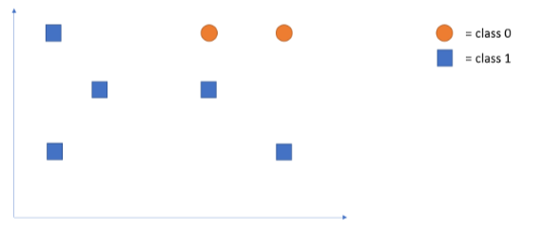



1. Data set below (x and O) will never give zero training error if adaboost is using simple decision stumps (as decision stumps must be horizontal or vertical lines)

| X O  
 | O X  
 |------------

1. New weights, from top to bottom, are: {0.1, 0.4, 0.2, 0.3}

Q3

1. Book work
2. Book work
3. 0.962